.



**\*\*Exploration of Scenic Northern India: A Journey from Pune to Jammu\*\***

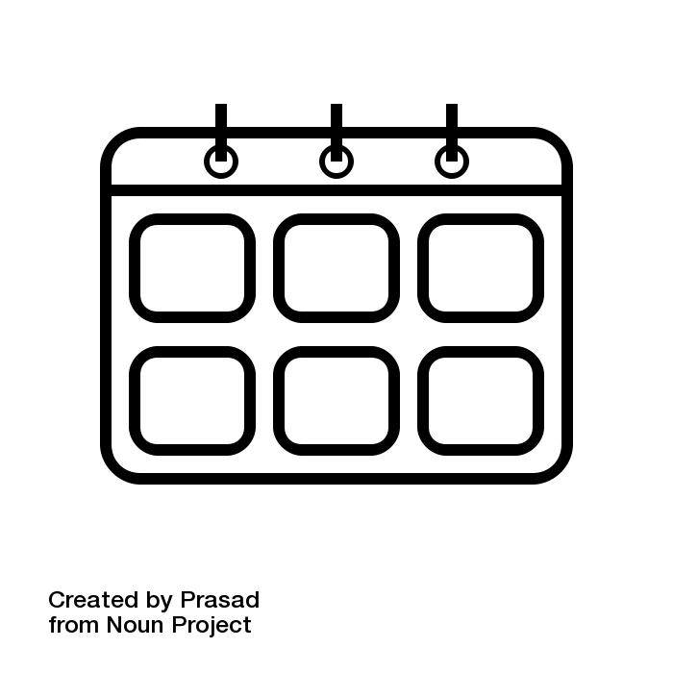 Number of Days : 15

 Budget Per Person : Rs. 19000

 Cities : Jammu



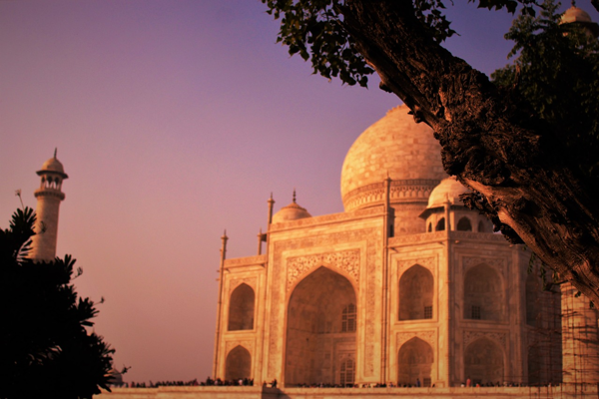

**Day 10: Cultural Insights in Srinagar**

Travel: Local sightseeing in Srinagar | Proceed to Jammu   
Explore Mughal Gardens and Shankaracharya Temple in Srinagar. Experience local market culture and buy handicrafts. Post-lunch, travel to Jammu, recounting the trip’s highlights, arriving by evening. Settle into our hotel and enjoy a group dinner reflecting on the journey so far.  
  
---



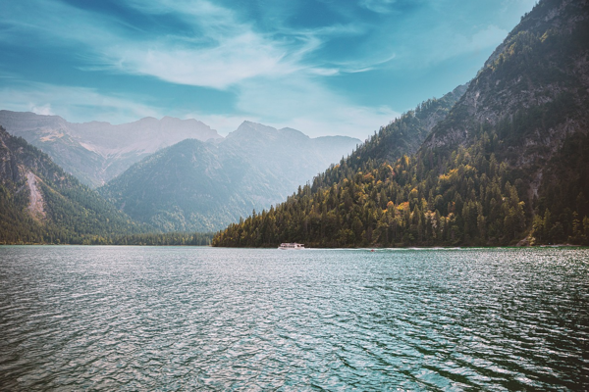

**Day 11: Farewell to Jammu's Splendor**

Travel: Local sightseeing in Jammu   
After breakfast, visit Raghunath Temple and Ranbireshwar Temple, exploring the spiritual heritage. Afternoon visit to Mansar Lake for a scenic walk. In the evening, reflect on our trip at a farewell dinner, fondly expressing gratitude for our experiences together.  
  
---



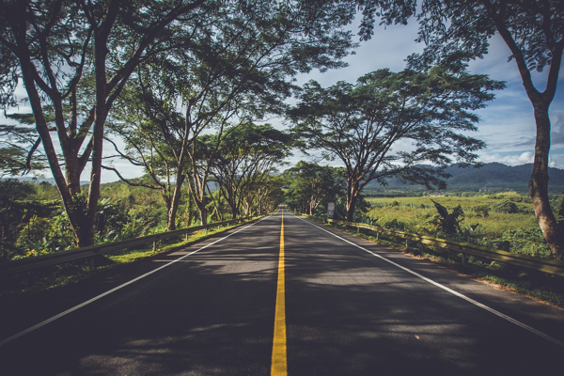

**Day 12: Returning Journey**

Travel: Jammu to Delhi | Distance: 600 km | Time: 12 hours   
Early morning departure for Delhi by bus. Enjoy light snacks and games en route, reminiscing about the past days. Arrive in Delhi by evening and check into a hotel. Free time for rest, preparing for a long train journey ahead.  
  
---



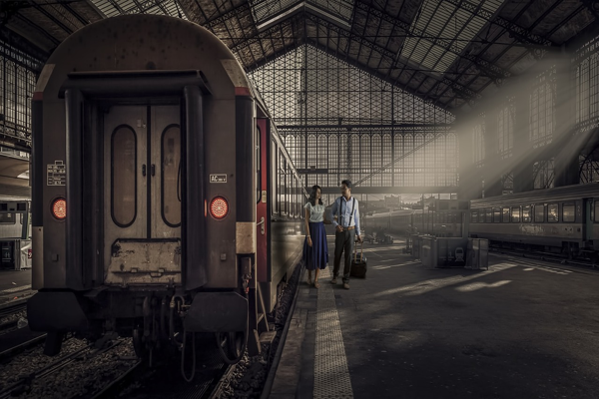

**Day 13: Scenic Train Ride Back to Pune**

Travel: Delhi to Pune | Distance: 1,200 km | Time: 23 hours   
Morning train to Pune! Enjoy onboard activities as a group: music, quizzes, and sleep. Share your favorite memories and future plans. Arrival in Pune next day, concluding our educational and adventurous journey across Northern India.  
  
---





**Day 14: Arrival and Reflection in Pune**

Travel: Local leisurely activities   
Arrive in Pune, and take the day to rest and reflect on the experiences. Share photos and memories with friends and family. Consider planning a follow-up meet to discuss favorite moments and learnings from the trip over snacks!  
  
---



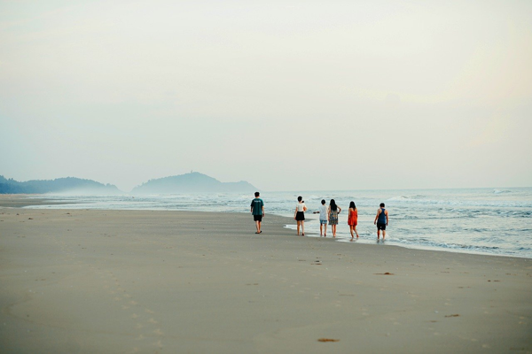

**Day 15: The Journey of a Lifetime**

Travel: Relaxing day in Pune   
Gentle start to the day. Celebrate the shared experiences with a gathering. Discuss plans for future group outings and tie up loose ends from the trip. Reflect on the educational insights gained, friendships forged, and beautiful memories created.



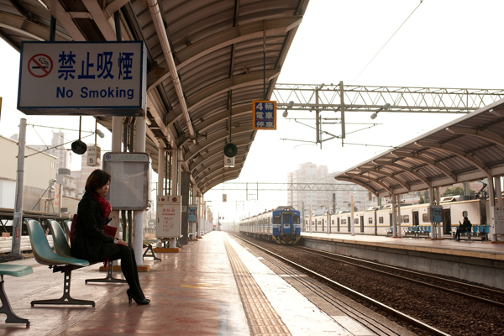

**Day 1: Experiencing the Wonder of Trains**

Travel: Pune to Agra | Distance: 1,200 km | Time: 23 hours   
Gather at Pune station early morning for our exciting train journey to Agra! Enjoy group games and share stories during the ride. Bring snacks for the long haul. Evening arrival in Agra, settle into the hotel, and rest for the next day’s adventures.  
  
---



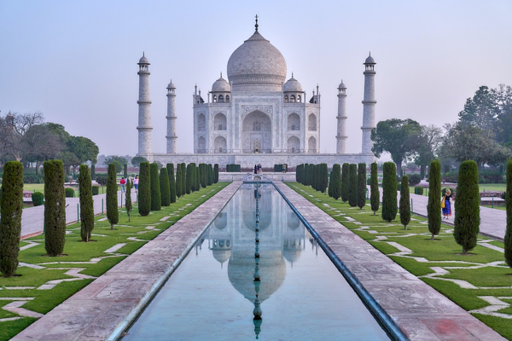

**Day 2: Majestic Arrival in Agra**

Travel: Local sightseeing in Agra   
Wake up to a grand breakfast and head to the iconic Taj Mahal! Marvel at its beauty and learn about Mughal architecture. Afternoon visit to Agra Fort, enriching our knowledge of Indian history, followed by a relaxing evening. Group dinner to discuss today’s experiences.  
  
---



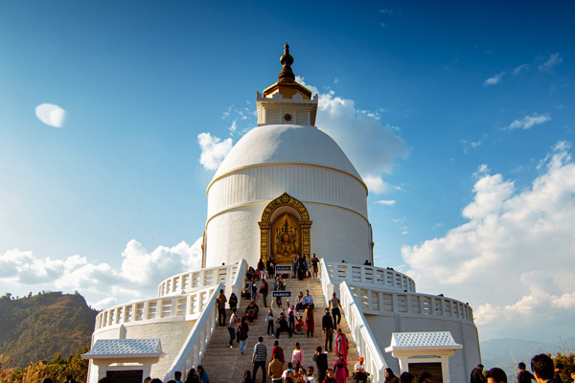

**Day 3: Divine Tour of Mathura and Vrindavan**

Travel: Agra to Mathura | Distance: 60 km | Time: 1.5 hours   
Post breakfast, let's visit Mathura, the birthplace of Lord Krishna. Witness its vibrant culture at Birthplace Temple. Then, off to Vrindavan to explore stunning temples and enjoy peaceful gardens. Return to Agra for dinner and share insights from the day’s enlightening visits.  
  
---



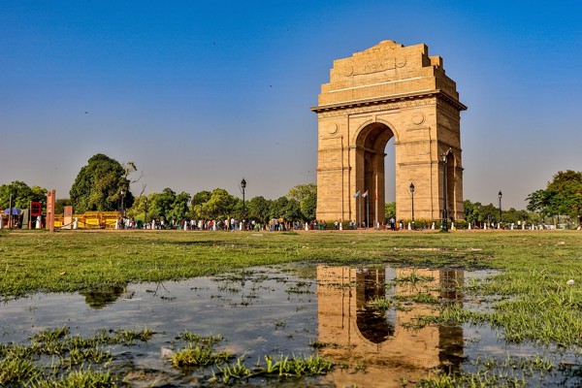

**Day 4: Journey to the Capital City - Delhi**

Travel: Agra to Delhi | Distance: 200 km | Time: 4 hours   
After breakfast, embark on our journey to Delhi! Upon arrival, check in to our hotel, then let’s explore historical sites. Afternoon visit to India Gate and Humayun’s Tomb, absorbing the capital's essence. Evening free for shopping at Connaught Place, leaving some time for reflection.  
  
---



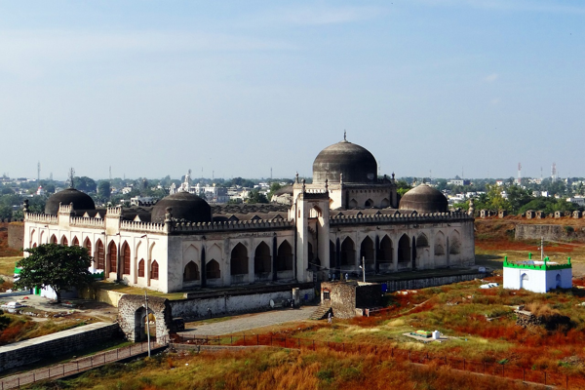

**Day 5: Delving Deeper into Delhi's Heritage**

Travel: Local sightseeing in Delhi | Night journey for Amritsar   
Explore the streets of Old Delhi in the morning: visit Jama Masjid and enjoy street food. Afternoon tour of Qutub Minar and Lotus Temple for architectural marvels. Dinner at a local restaurant before boarding the overnight bus to Amritsar.  
  
---



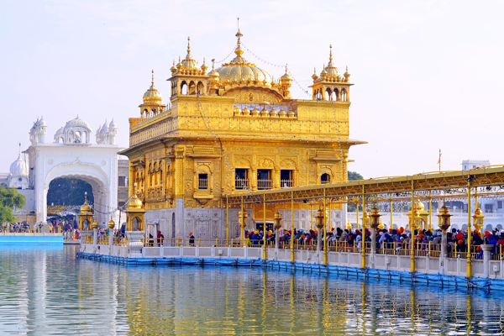

**Day 6: The Spirit of Amritsar**

Travel: Local sightseeing in Amritsar   
Arrive in the early morning, starting at the majestic Golden Temple. Engage in the prayers and taste the famous langar. Afternoon at Jallianwala Bagh and the Partition Museum, enriching our educational understanding. Evening visit to the Wagah Border ceremony.  
  
---



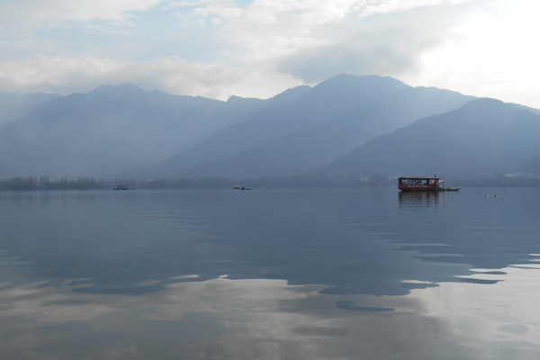

**Day 7: Scenic Journey to Srinagar**

Travel: Amritsar to Srinagar | Distance: 450 km | Time: 10 hours   
Morning departure for Srinagar. Enjoy picturesque landscapes on the way, stopping for snacks. Arrive and check into a houseboat, experiencing local hospitality. Evening stroll along Dal Lake, appreciating the serene beauty before settling in for a cozy night.  
  
---



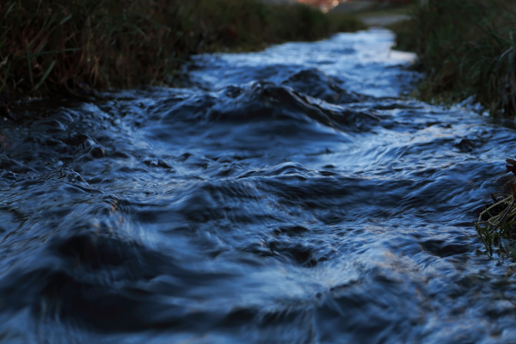

**Day 8: Enchanting Sonamarg Excursion**

Travel: Srinagar to Sonamarg | Distance: 80 km | Time: 2 hours   
After breakfast, set off for Sonamarg, known for its stunning vistas. Engage in local sightseeing, perhaps a boat ride on the Sindh River! Explore stunning glaciers and enjoy a packed lunch outdoors. Return to Srinagar for a comforting dinner and sharing moments from the day.  
  
---



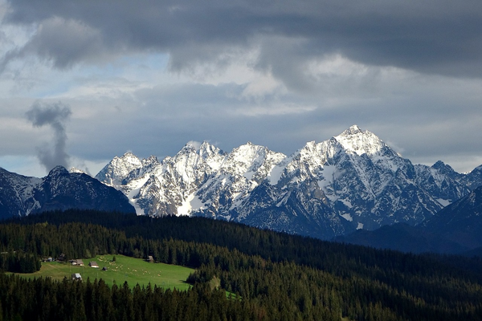

**Day 9: Adrenaline Rush in Gulmarg**

Travel: Srinagar to Gulmarg | Distance: 50 km | Time: 1.5 hours   
Early morning departure to Gulmarg for snow sports and captivating mountain views. Participate in skiing or simply savor the winter landscape. Toast marshmallows by a bonfire in the evening, sharing stories and laughter before heading back to Srinagar for rest.  
  
---

.



Acommodation Details

|  |  |  |
| --- | --- | --- |
| City | Hotel | Price |
| Agra | 5-6 sharing basis | 0 |
| Delhi | 5-6 sharing basis | 0 |
| Amritsar | 5-6 sharing basis | 0 |
| Srinagar | 5-6 sharing basis | 0 |
| Jammu |  | 0 |

Local Transport Details

|  |  |  |
| --- | --- | --- |
| City | Car | Fare |
| Agra | 50 Seater Non AC Bus | 0 |
| Delhi | 50 Seater Non AC Bus | 0 |
| Amritsar | 50 Seater Non AC Bus | 0 |
| Srinagar | 50 Seater Non AC Bus | 0 |
| Jammu | 50 Seater Non AC Bus | 0 |



**INCLUSIONS:**

* Accommodation on twin/triple sharing basis.
* All interstate taxes, permits, parking, road tax, toll taxes and fuel charges etc included.
* All government applicable taxes and service charges.

**EXCLUSIONS:**

* Personal expenses such as laundry, telephone calls, tips, liquor, boating & joy rides.
* All kind of personal expenses such as tips, laundry, telephone bills and beverages, Camera Fees.
* Cable Car Tickets, Any meals unless and otherwise specifically mentioned.
* Any claim due to road blocks, curfew, accident etc.
* Any other items which not specified in “Cost Inclusions”.